**An Easy Read guide to using an Amazon Echo Dot**

**What is an Amazon Echo Dot?**

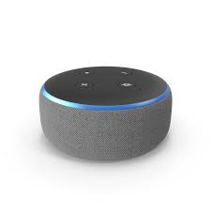

An Echo Dot is a small device which acts as a speaker.

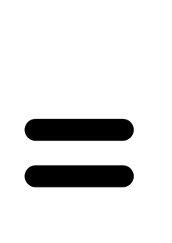 

The speaker is an Amazon Echo device and this means that it is linked to a virtual assistant called Alexa.



*(Alexa is not a real person)

It uses the internet so we call it a smart speaker.

  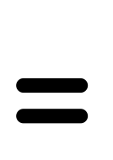 

You can ask Alexa questions or give her instructions.

 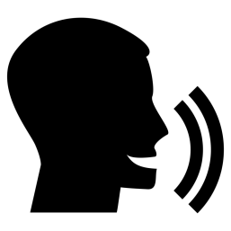

Lot's of other devices can be set up to work with your Echo Dot.

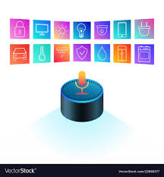

**Setting up your Echo Dot**

You will need to have an Amazon account (this does not cost you any money).

 

You will need a smart phone or a tablet.

 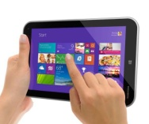

You will need to know your WiFi password

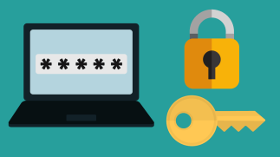 Something like: AK6mndsT7ssd

**What you need to do:-**

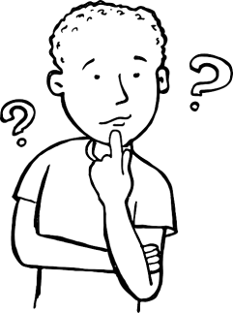

Search for the Amazon Alexa app in the play store.

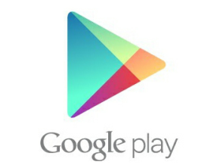 

When you find the Amazon app, click on ‘download’

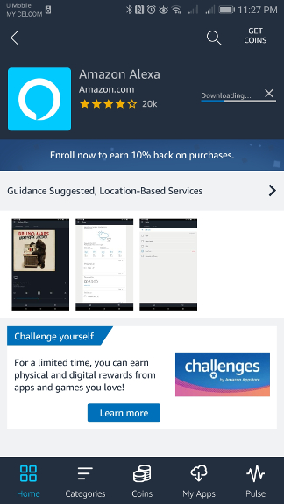

When you have downloaded the app, you log in with your Amazon account details.

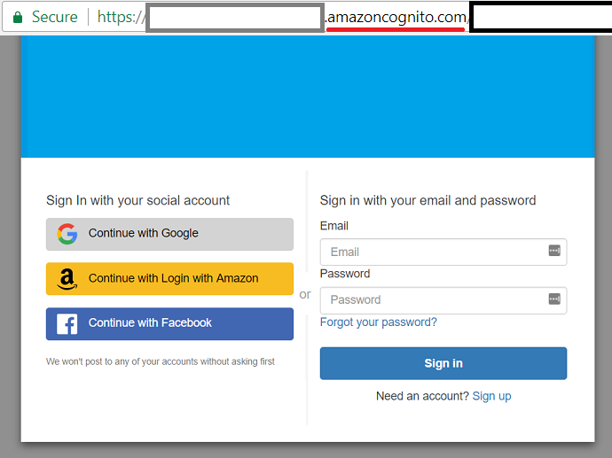

Take your Echo Dot out the box and plug it in to a plug

 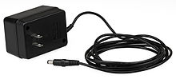

On the app on your smart phone or tablet, click on ‘device’s’

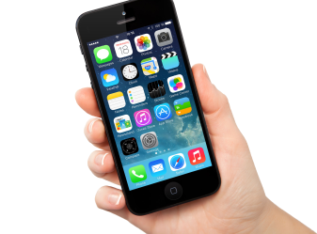 

Click on the + symbol



Click ‘add device’

 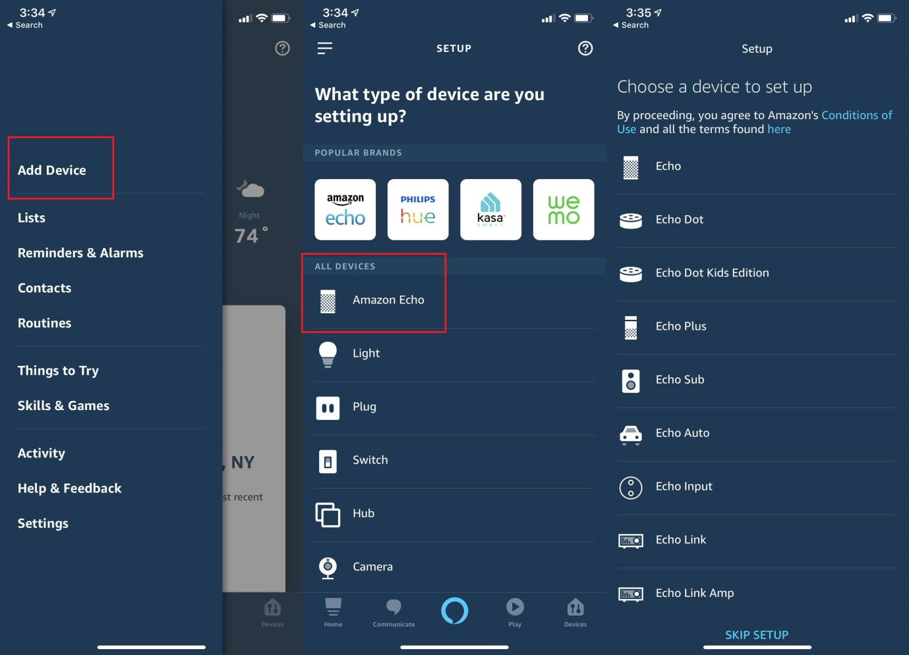

Click ‘Amazon Echo'

 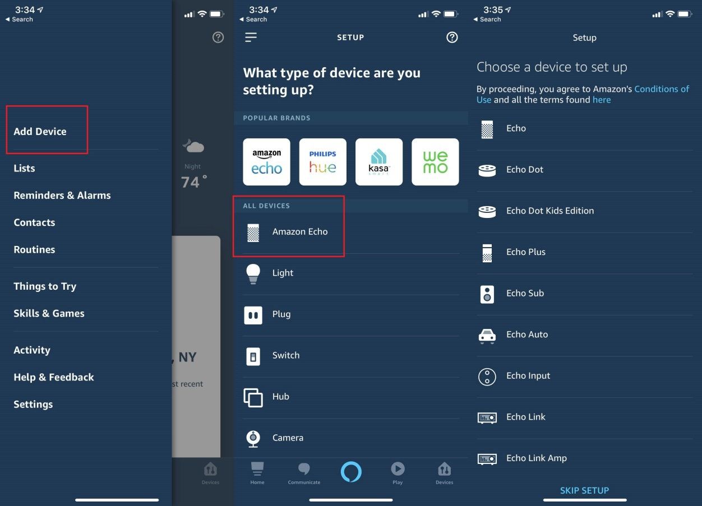

Click ‘Echo Dot’

 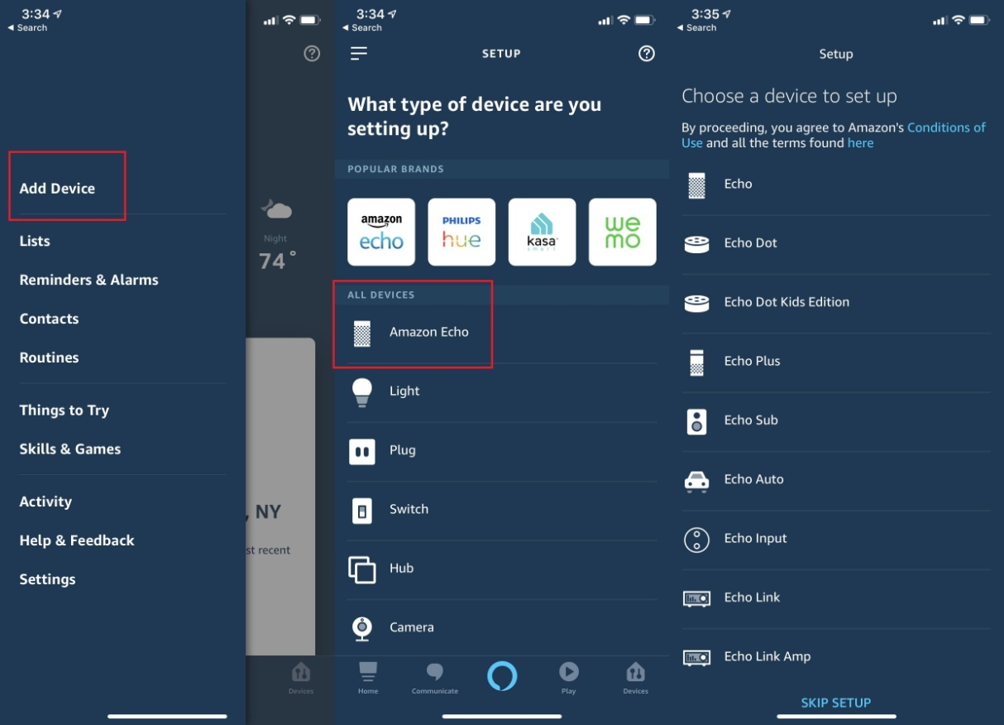

Click ‘3rd generation’

Click ‘yes’ if you have plugged your dot in and if there is an orange circle lit up on it.

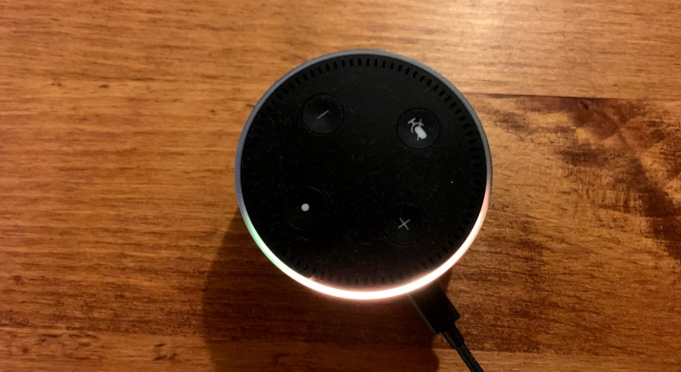 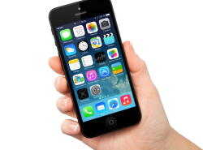 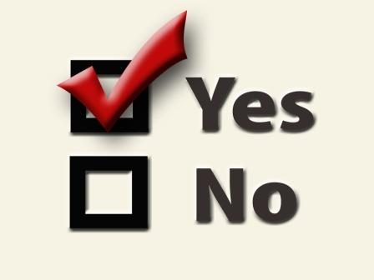

The app will ask you for Wi-Fi password:

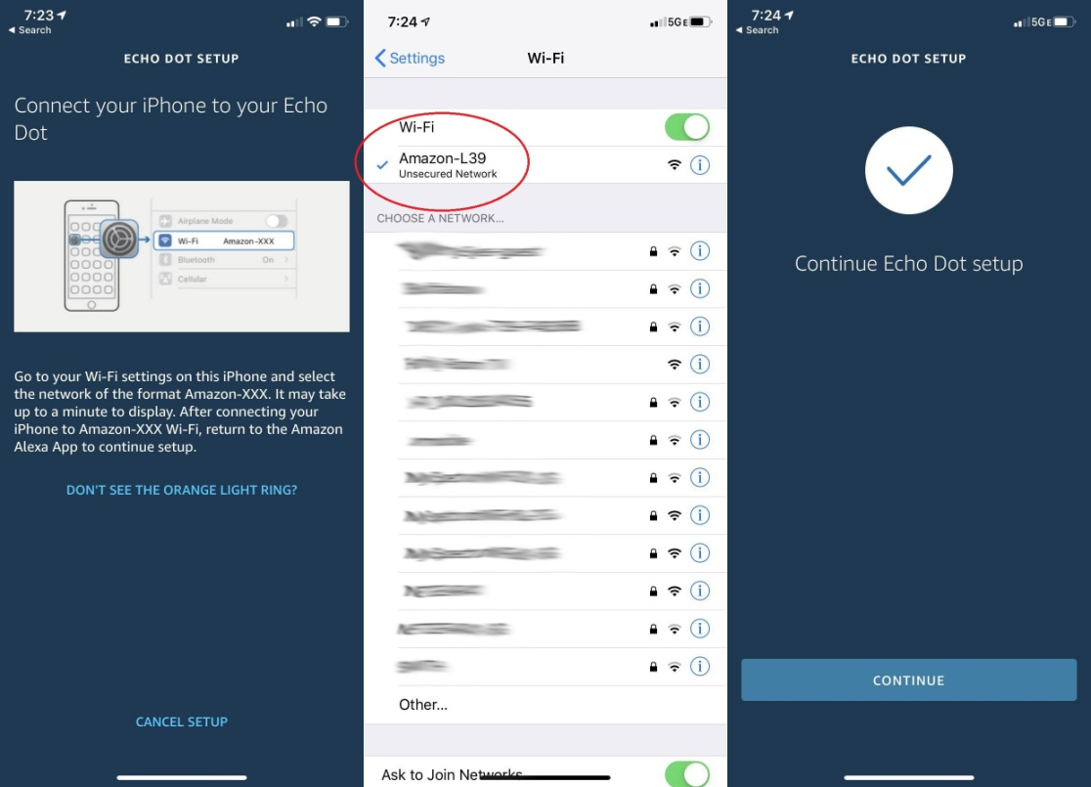

The app will find your dot



It will ask you a few questions to get it setup



You can start using your Dot by speaking to it.

You wake it up by saying ‘Alexa'

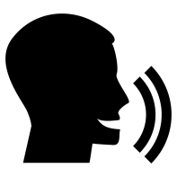 ”Alexa, Good Morning”

You don't need to use the app again unless you are changing things or setting up something new.

 

Leave the app on your phone or tablet.

**What can you do with your Echo Dot?**

**You can ask questions, here are some to try:-**

“Alexa, what is the weather like today?”

 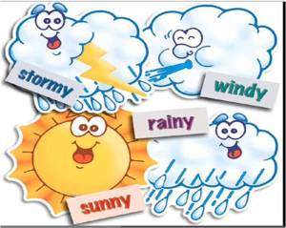

“Alexa, how do I spell candle?”

 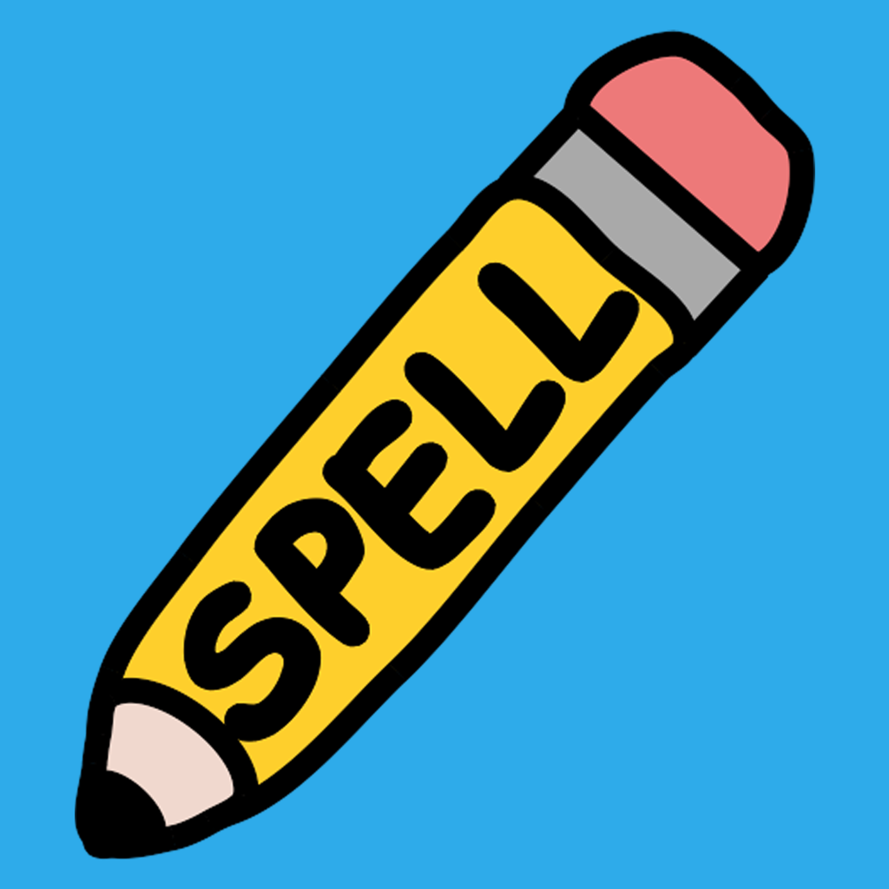

“Alexa, what is 2 plus 3?”

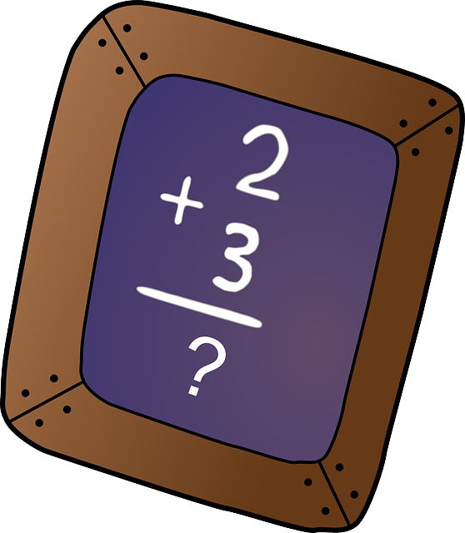

“Alexa, set an alarm for ten past ten AM”

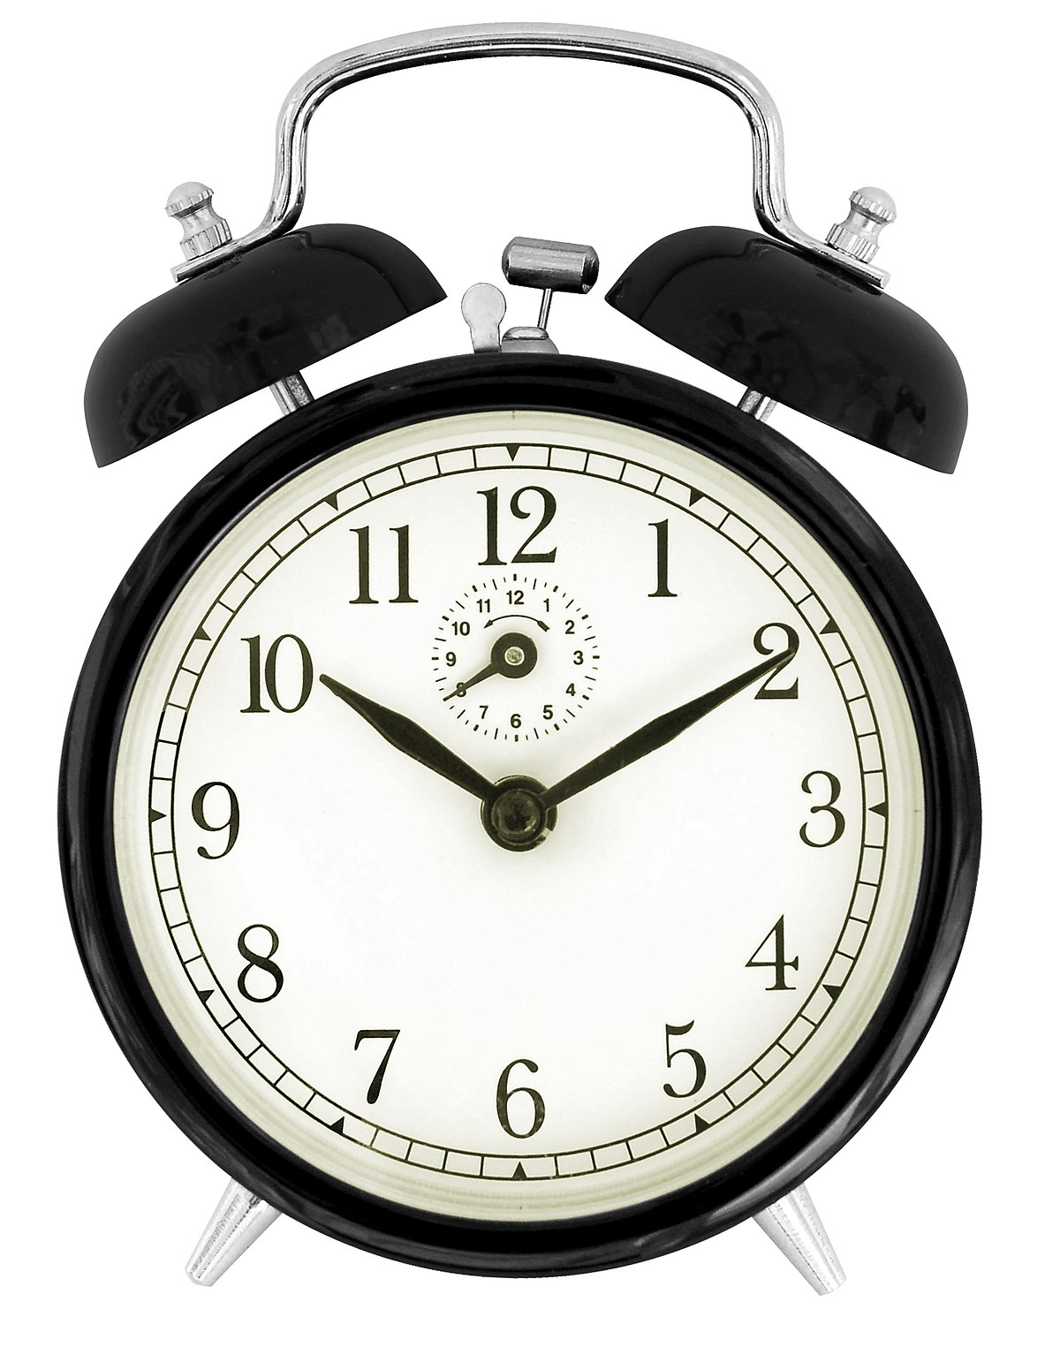

“Alexa, set a timer for 5 minutes”

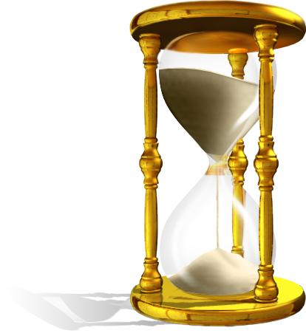 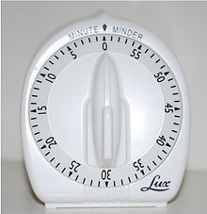

“Alexa, set a reminder for 1 PM to eat my lunch”

 

“Alexa, add eggs to my shopping list”

 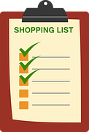

“Alexa, what's on my shopping list?”

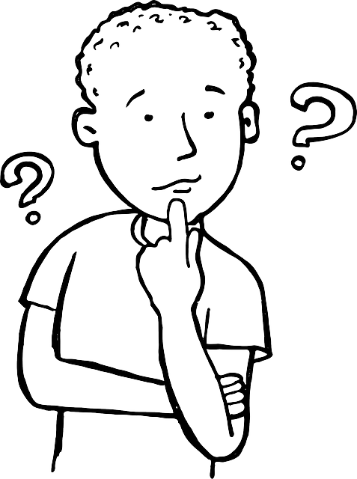 

“Alexa, play pop music”

 

“Alexa, play Heart FM radio”

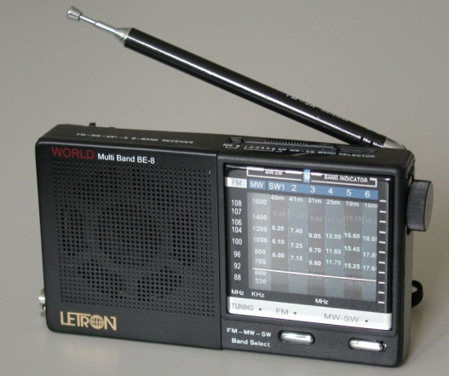 

“Alexa, tell me a joke”

 

“Alexa, what's the news”

 

“Alexa, play a mindfulness meditation”

  

If Alexa is not able to understand your question, just wait a minute and try again.

 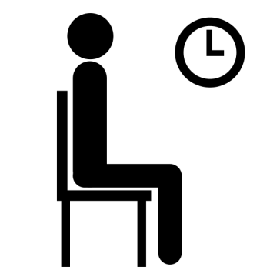 

If you want Alexa to stop talking, just say “**Alexa, stop”**

 

**Sometimes the first time you try something, Alexa might ask you to enable a skill first.**

**A ‘skill’ is a special kind of app just for Alexa**

**To do this, you say “Alexa, enable “ and then the name of the skill. For example, “Alexa, enable Heart FM radio skill”**

**If you have Amazon prime, you can ask Alexa to play a song or albumn.**

**If you don't have Amazon prime, Alexa might ask if you want it – you just say “no” if she asks.**