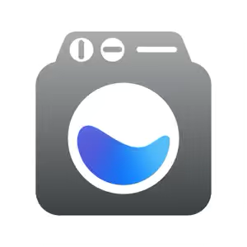

**Laundry Lens app for iPhone users**

Coalition member Brian has kindly written up an app review for us all to introduce us to an app called Laundry Lens which is available to iPhone users.

**What is it and who is it for?**

The Laundry Lens app is for anyone who wants to know what the symbols on their clothing labels mean! It is particularly helpful for those of us with low vision or people who are completely blind to give some help when it comes to washing clothing.

**What does the app do?**

The app allows the user to access information on the tags on their clothing to identify the symbols and washing instructions. As an example, the instruction to avoid tumble drying or to wash on a low heat or to not iron.

**How much does it cost?**

The app is completely free

**How easy is it to use?**

The app is simple and straightforward to use. It is a very handy little app.

You will need to start by finding the app in the app store by searching for ‘laundry lens’ and then downloading it. Once the app is downloaded from the App Store you simply point your phones camera over the garment label and it quickly scans all the symbols very quickly. At the bottom of the screen is a blue bar that says instructions and once this is selected it will show you all the symbols on the screen and the instructions of how to wash your clothing. It is best to use voice-over when using this application as it does not announce straight away. It can read all the instructions from the clothing label.

**How do I get it?**

The link to the app on the app store is here: <https://apps.apple.com/gb/app/laundry-lens/id1513767864>

**What do the screens look like?**

Brian has included two screen shots of each stage and they are below:

**Screen shot 1**

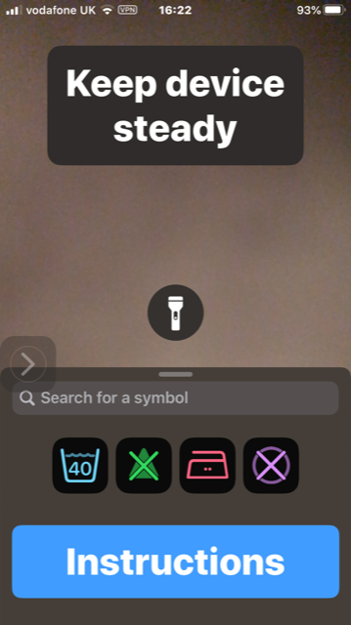

**Screen shot 2**

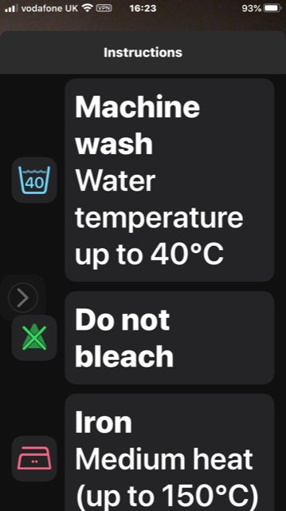

**What about android users?**

This app is not currently available for android users but there are a few different android alternatives which we would love a member to review for us – please get in touch if you are interested!