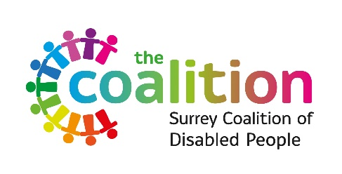

Pathways to Change:
Exploring South-Asian adults views of mental health services in Surrey and North-East Hampshire since 2017.
PARTICIPANT CONSENT FORM

Before you decide to take part, please read the accompanying Participant Information Sheet.
This form is to confirm that you understand what the purposes of the research project are, what will be involved and that you agree to take part. If you are happy to participate, please tick each box to indicate your agreement, sign and date the form, and return to the researcher.
- Taking part in the study
I have read and understood the participant information sheet, or it has been read to me. I have been able to ask questions about the study and my questions have been answered to my satisfaction.
I consent voluntarily to be a participant in this study and understand that I can refuse to answer questions and I can withdraw from the study at any time, up until Monday 24th April, without having to give a reason.
I understand that the survey / focus group will be recorded for the purposes of transcription.
- Use of information in this study
I understand that the information I provide will be used for reports, presentations, and short films (which will available online).
I agree that my information can be quoted in research outputs.
I understand that all information I provide will be kept confidential and stored securely, and that only the researcher will have access to it.
Name of Participant | Date | Signature
Name of Researcher | Date | Signature
Please do not hesitate to ask questions if anything is unclear or if you would like more information about any aspect of this research. It is important that you feel able to take the necessary time to decide whether you wish to take part.

