Pathways to Change: Definitions
Religious needs
Religious practices or beliefs

“of, relating to, or involved with religion, or living and worshiping according to the beliefs of a particular religion.”
(Cambridge Dictionary)
Cultural needs
The needs of an individual which are linked to their cultural identity.

“Cultural identity or heritage can cover a range of things. For example, it might be based on ethnicity, nationality or religion. Or it might be to do with the person's sexuality or gender identity”
(CQC)

“The way of life, especially the general customs and beliefs, of a particular group of people at a particular time. The attitudes, behaviour, opinions, etc. of a particular group of people within society.”
(Cambridge Dictionary)

“Culturally appropriate care (also called 'culturally competent care') is sensitive to people's cultural identity or heritage. It means being alert and responsive to beliefs or conventions that might be determined by cultural heritage.”
(CQC)

Mental ill-health
Experiencing difficulties with your emotional and psychological wellbeing

These are just some, not all, of the examples of mental ill-health:
- Feeling sad for a long period of time
- Having panic attacks
- Feeling very worried about lots of different things
- Struggling to cope with stress
- Having thoughts about hurting yourself

“Good mental health means being generally able to think, feel and react in the ways that you need and want to live your life. But if you go through a period of poor mental health you might find the ways you're frequently thinking, feeling or reacting become difficult, or even impossible, to cope with.”
(Mind)

Mental health services
Services which provide support for mental health

Examples are:
- Seeing your GP
- Going to A&E (Accident & Emergency)
- Staying in a Mental Health Hospital
- Visiting Safe Havens in person or online
- Calling the Crisis Line
- Seeing the Home Treatment Team (HTT)
- Seeing the Community Mental Health Team (CMHT, also known as CMHRS)
- Using the Recovery College
- Having Cognitive Behavioural Therapy (CBT)
- Seeing an Occupational Therapist
- Being part of a support group

Someone who provides support
Anyone who is providing support to a family member, friend, or client for their mental ill-health.

Someone who has experienced mental ill-health
A person who is using or has used mental health services.

Examples are:
- Being a patient in a mental health ward
- Using community services such as counselling, GPs, the Recovery College, the Crisis Line

For more information about this research project, please visit: https://surreycoalition.org.uk/imhn/blogs/research-blogs
 |  | 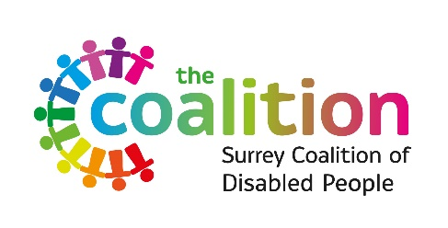
smef.org.uk | surreycoalition.org.uk/imhn | surreycoalition.co.uk

