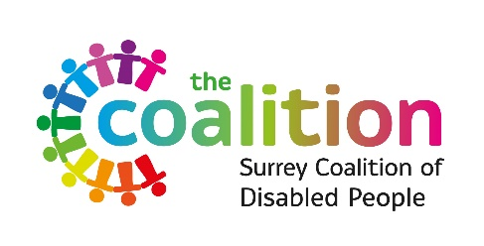
Pathways to Change:
Exploring South-Asian adults and their carers’ views of mental health services in Surrey and North-East Hampshire since 2017.
Participant Debrief Sheet
Thank you for participating in our survey/research conversation/focus group. We hope that you have found it interesting and have not been upset by any of the topics discussed. However, if you have found any part of this experience to be distressing and you wish to speak to someone, please contact Salem Sabur at salems@smef.org.uk or by 07915 926 753.
There are also several organisations listed below that you can contact.
- Safe Havens (in person and online out of hours drop-in service)
Based at Aldershot, Epsom, Guildford, Redhill and Woking.
Website: www.sabp.nhs.uk/our-services/mental-health/safe-havens
- Samaritans
Call 116 123 (Open 24/7)
Email: jo@samaritans.org
Website: www.samaritans.org
- Shout
Text ‘Shout’ to 85258 (Open 24/7)
Website: www.giveusashout.org
- Surrey and Border’s Mental Health Crisis Helpline
Call: 0800 915 4644
Text: 07717 989 024

- Action for Carers Surrey
Helpline: 0303 040 1234 (Open Mondays, Thursdays and Fridays; 9am-5pm and Tuesdays and Wednesdays from 9am to 6pm)
Email: CarerSupport@actionforcarers.org.uk
Website: www.actionforcarers.org.uk
- BASRRA (Bereavement Advice and Support, Redhill and Reigate Area)
Website: basrra.org
- East Surrey Domestic Abuse Service (ESDAS)
Covers Reigate, Banstead, Mole Valley and Tandridge
Call: 01737 771 350 (9am – 4pm)
Text: 07860 039 720
E-mail: support@esdas.org.uk
Website: www.esdas.org.uk
- Shifa Network – Asian Women’s Wellbeing Project (Based in Woking)
E-mail: admin@shifanetwork.org.uk
Website: www.shifanetwork.org.uk
- SMEF’s Trust Project
E-mail: admin@smef.org.uk
Website: smef.org.uk/domestic-abuse
- North Surrey Domestic Abuse Service (NSDAS)
Covers Elmbridge, Spelthorne, Epsom and Ewell
Call: 01932 260690 (Open Monday – Friday, 9:30am – 4pm)
E-mail: nsdas@caew.org.uk
Website: www.nsdas.org.uk
- South West Surrey Domestic Abuse Service (SWDAS)
Covers Guildford and Waverley
Call: 01483 898884 (Open Monday – Friday, 9am – 4pm)
E-mail: swr@swsda.org.uk
Website: www.swdas.org.uk
- Your Sanctuary (Supporting those affected by domestic abuse)
Helpline: 01483 776822 (Open every day, 9am – 9pm)
Website: www.yoursanctuary.org.uk (Online chat available Monday – Friday, 9:30 am – 5pm)

