**Easy read survey about health and wellbeing services**



**This survey is for anyone living in Surrey and North East Hampshire.**

**The NHS and the Independent Mental Health Network want to make sure everyone can access local mental health services.**

**We also want to know what changes can be made to make the services better for you.**

**If this survey makes you feel upset then you can speak to someone you trust, like a friend or carer.**

**Your answers will be kept private.**

**If you have any questions you can email Charlotte:**

**charlotte.payne@surreycoalition.org.uk**

**Or call or text Charlotte:**

**07492 249 513**

**Part 1 – Questions about you**

**Question 1:**

**How old are you?**

**Question 2:**

**The next questions are about who you are attracted to.**

Being **attracted** to someone means that you would like to kiss or have sexual intercourse with them.

**Are you happy to answer questions about who you are attracted to?**

**Yes: please go to Question 2A**

**No, please go to Question 3**

**Question 2A: Are you Straight or Heterosexual?**

**Straight** or **Heterosexual** means that you are a woman who is only attracted to men, or a man who is only attracted to women.

**Question 2B: Are you Gay or a Lesbian?**

**Gay** means that you are a man who is only attracted to other men. **Lesbian** means that you are a woman who is only attracted to other women.

**Question 2C: Are you Bisexual or Queer?**

**Bisexual** means that you are attracted to both men and women. Being **queer** means that you aren’t just attracted to men or women. You might be attracted to people and them being a man or woman doesn’t matter. Or you might not be attracted to anyone.

 

**Question 3:** 

**The next questions are about your gender.**

 Your **gender** means if you feel like a man or woman.

**Are you happy to answer questions about your gender?**

**Yes: please go to Question 3A**

**No, please go to Question 4**

Are you a man or a woman?

**Man** please go to Question 4

**Woman** please go to Question 4

**I would like more options** please go to Question 3

Are you non-binary? Non-binary means that you feel that you have no gender, that you are not a man or a woman.

Are you gender fluid? Gender fluid means that you may feel like you are more a man one day and more a woman a different day.

Are you transgender? Transgender means you are a man who was born into a woman’s body or that you are a woman who was born into a means body.







  

What is your ethnicity?

White

Black

Roma or Irish Traveller

Asian

More than one ethnicity

Arab

Other

I don’t want to say

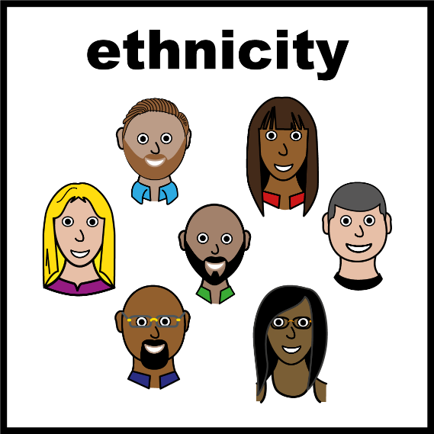

1. Do you consider yourself disabled?

*For example, long-term health conditions, physical, learning, and mental health*

Yes

No

Prefer not to say

Other, please specify:

1. Do you identify as neurodivergent?

*Choose all that apply, you do not need a diagnosis*

No

Attention Deficit Hyperactivity Disorder *(ADHD/ADD)*

Autism *(ASC/ASD/Asperger's)*

Dyscalculia *(Difficulty in understanding numbers)*

Dyslexia *(Difficulty reading, writing, and spelling)*

Dyspraxia *(Developmental Coordination Disorder/DCD)*

Tourette’s Syndrome

Prefer not to say

Other, please specify:

1. Do you support someone experiencing mental or physical health difficulties who couldn’t manage without your help?

Yes

No

Unsure

Prefer not to say

1. What borough



**Section 2 – Accessing Support in the Community**

These questions are to gain an understanding of barriers that might deter you from seeking support.

1. Who would you reach out to if you were struggling to cope with day-to-day life at any time, for example, you felt very worried or sad or had stopped going out as much as usual?

*Choose all that apply*

Friends, Family, or Spouse

GP 

Safe Haven 

Charity Services (such as, Counselling) 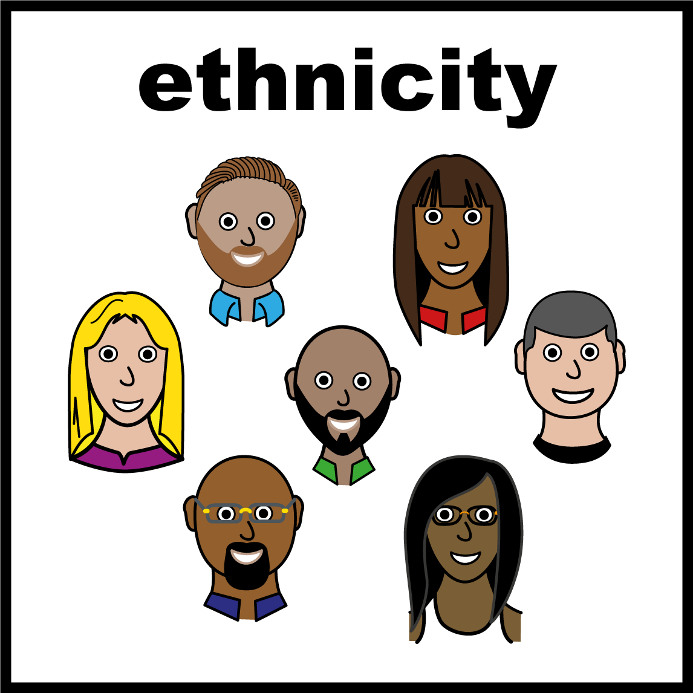

Peer Support Groups

Community Leaders

Emergency Services or 111

Crisis Line or Single Point of Access

No-one

Other, please specify:

1. What do you feel are potential barriers to you seeking support when you are struggling to cope with day-to-day life?

*Enter your answer*

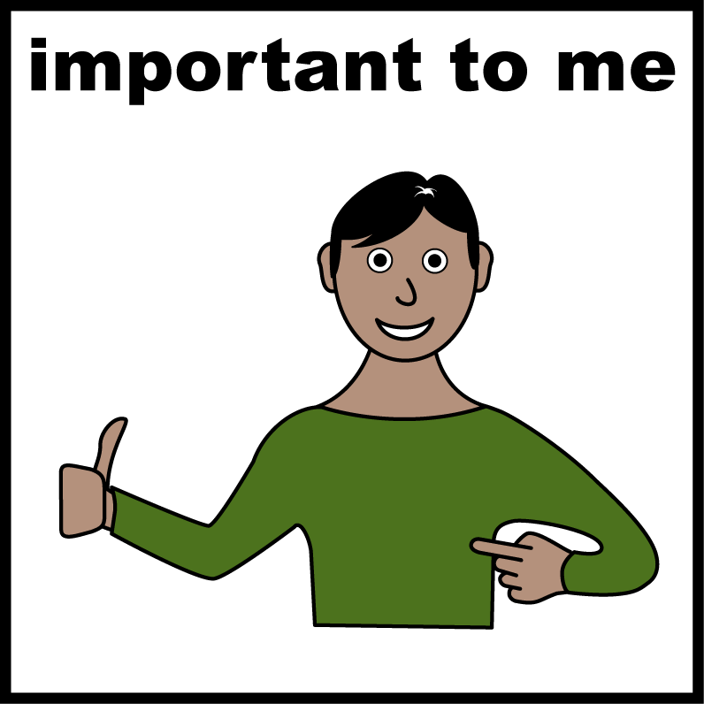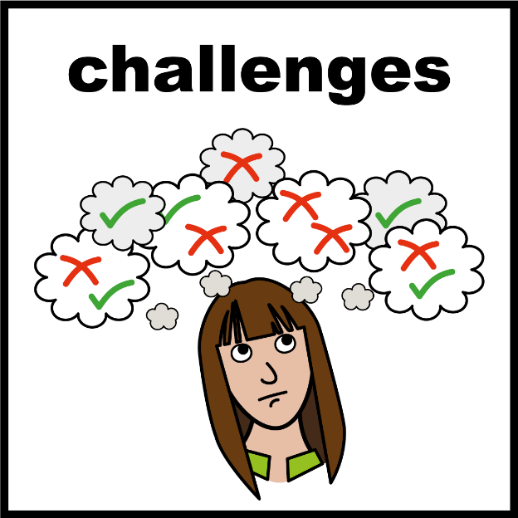

**Section 3 – Experience of Support in the Community**

These questions are to gain an understanding of the experiences you have had when accessing support in the community.

Please answer the multiple choice with your standard experience of services. You are welcome to detail any exceptions to your choice or example experiences in the "Would you like to provide more information?" sections.

1. I feel listened to and respected when discussing my needs with organisations providing support.

Strongly Agree

Agree

Neutral

Disagree

Strongly Disagree

Unsure/Not applicable

1. Would you like to provide more information?

*Enter your answer*

1. I feel that organisations providing support will understand my individual needs.

Strongly Agree

Agree

Neutral

Disagree

Strongly Disagree

Unsure/Not applicable

1. Would you like to provide more information?

*Enter your answer*

1. I feel that organisations are well-informed about issues relating to diverse needs.

*For example age, ethnicity, gender and sexual identity, disability, and other characteristics.*

Strongly Agree

Agree

Neutral

Disagree

Strongly Disagree

Unsure/Not applicable

1. Would you like to provide more information?

*Enter your answer*

1. I feel that organisations are well-informed about what other services are available to meet diverse needs.

*For example age, ethnicity, gender and sexual identity, disability, and other characteristics.*

Strongly Agree

Agree

Neutral

Disagree

Strongly Disagree

Unsure/Not applicable

1. Would you like to provide more information?

*Enter your answer*

1. I am concerned that I may experience discrimination, prejudice, or assumptions being made by organisations that provide support services.

Strongly Agree

Agree

Neutral

Disagree

Strongly Disagree

Unsure/Not applicable

1. Would you like to provide more information?

*Enter your answer*

**Section 4 – Final Comments**

1. What would make accessing health and wellbeing support easier for you?

*Enter your answer*

1. Do you have any other comments?

*Enter your answer*

**Section 5 – End of Survey**

Thank you for completing this survey.

1. Are you happy to be contacted by a member of our team to speak with you more about your thoughts on this topic?

Yes, I am open to discussing this further

No, just submit anonymously

1. If yes, please enter your contact information

*Email or telephone number*

**Please submit this response to Charlotte Payne.**

Email: charlotte.payne@surreycoalition.org.uk

Call/text: 07492 249 513

Post:

Charlotte Payne

Surrey Coalition of Disabled People

Astolat

Coniers Way

Burpham

GU4 7HL

To learn more about this project, you are welcome to contact Co-production and Community Engagement Officers:  
  
Charlotte Payne | charlotte.payne@surreycoalition.org.uk  
Wendy Smith | wendy.smith@surreycoalition.org.uk  
Megan Siarey | megan.siarey@surreycoalition.org.uk

If you have been affected by this research, you may wish to contact your GP or the following organisations: 

* **Samaritans**  
  Call 116 123 (Open 24/7)  
  Email: jo@samaritans.org  
  Website: www.samaritans.org
* **Shout**  
  Website: www.giveusashout.org  
  Text ‘Shout’ to 85258 (Open 24/7)
* **Surrey and Border’s Mental Health Crisis Helpline**  
  Call: 0800 915 4644  
  Text: 07717 989 024
* **Safe Havens (in person and online out of hours drop-in service)**  
  Based at Aldershot, Epsom, Guildford, Redhill and Woking.  
  Website: www.sabp.nhs.uk/our-services/mental-health/safe-havens