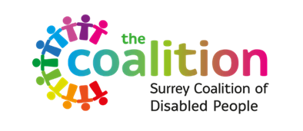
Disability Awareness & Accessibility in Surrey
Research Project Information Sheet
(Easy Read)
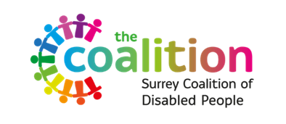 | Surrey Coalition of Disabled People is a charity. They help people with disabilities and long-term health conditions in Surrey.
 | The charity is doing a research project. They want to know more about what problems disabled people face when using businesses and services in Surrey.
 | The goal is to make things better by giving Disability Awareness Training. This training will be made with help from disabled people.
 | The research will show where the biggest problems are. This will help the charity know where to focus their efforts and money.
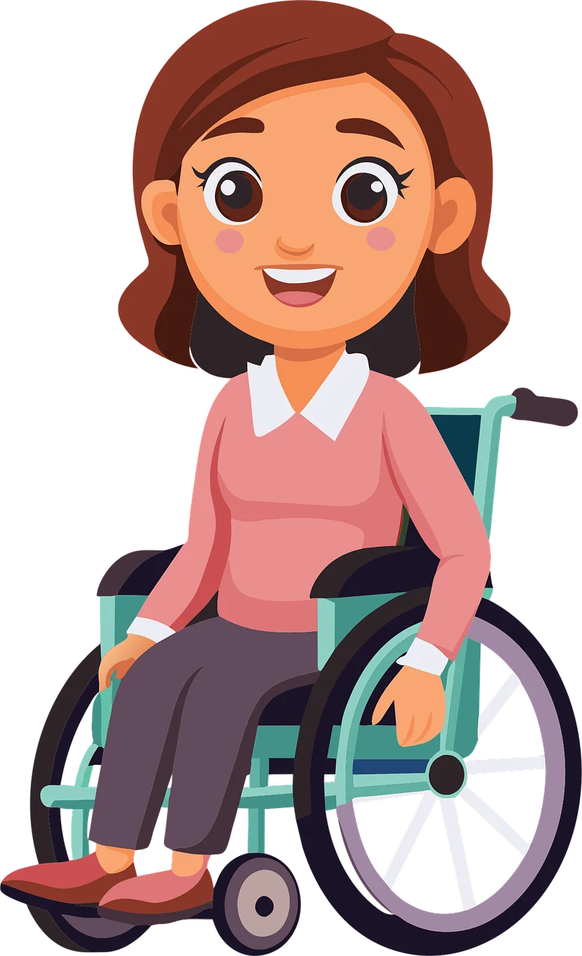 | They want to talk to people in Surrey who are 18 or older. These people should have a disability or long-term health condition.
 | You do not need to be a member of the charity to join the study. They want to hear from people with different experiences.
 | If you join, you will fill out a short survey online. It takes about 10-15 minutes.
 | If you need help to complete the survey our Involvement Officer, Megan, will be happy to assist you over the phone. Please contact her on 07454 759684 (weekdays 10am-4pm).
 | Some people can also join a focus group online. This is a meeting where you can talk more about your experiences.
 | The focus group is optional and lasts about an hour. You can just do the survey if you prefer.
 | You do not have to join if you do not want to. It will not affect any services you get.
 | If you join the focus group, it will be on Zoom. You need to contact Megan to book a place.  Email megan.taylor@surreycolaition.org.uk Phone/Text: 07454 759684
  8th July | The online focus group meeting will be help on Wednesday 8th July.  The meeting will start at 2:30pm and finish at 3:30pm.
 | The focus group will have only 10 people. If many people want to join, they might have another group later.
 | Everything you say in the group will be confidential. No one outside of the group will know it was you who said it.
 | If you change your mind, you can stop at any time. You can also ask for your information to be removed.
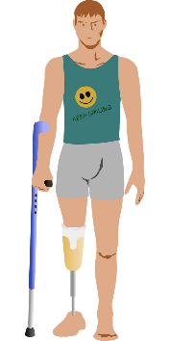 | The survey will ask about your disability and your experiences with businesses in Surrey.
 | Your answers will be anonymous. They will not use your name in the research report.
 | The results could help the charity get more funding. They will use the findings to improve their training.
 | Taking part can help make a positive change in Surrey. Your experiences can show where help is needed most.
 | Some questions might be upsetting. You can skip any questions you do not want to answer.
 | If you need support, there are places you can contact. They can help if you feel upset or need someone to talk to. A list of these places is at the bottom of this document.

Support is available from:
- Surrey and Borders (SABP) Mental Health Crisis Helpline: 0800 915 4644 or by SMS text: 07717 989 024
- Samaritans - Call 116 123 (free from any phone), 24 hours a day, 365 days a year.
- Safe Havens – Walk-in or virtual support, open 6pm to 11pm . sabp.nhs.uk/our-services/mental-health/safe-havens.
- 111 - If you call 111, you can select option 2 to access a 24/7 helpline offering urgent mental health support.
- MIND support line - 0300 102 1234. Open 9am to 6pm, Monday to Friday (except bank holidays).
- Campaign Against Living Miserably (CALM): 0800 58 58 58 (5pm–midnight every day) They also offer a CALM webchat service.
- SHOUT to 85258 If you would prefer not to talk but want some mental health support, you could text. Shout offers a confidential 24/7 text service providing support if you are in crisis and need immediate help.
- Papyrus HOPELINEUK: 0800 068 4141 (24 hours, 7 days a week), email pat@papyrus-uk.org or text 07786 209 697, people under 35.
- Switchboard. If you identify as gay, lesbian, bisexual or transgender, you can call Switchboard on 0300 330 0630 (10am–10pm every day), email chris@switchboard.lgbt or use their webchat service.

